Monday 26 January 2026
Organising Authority: Auckland Anniversary Regatta Inc.,
C/- Royal New Zealand Yacht Squadron, 101 Westhaven Drive, Westhaven 1011
Tel 0800-REGATTA E: admin@regatta.org.nz
In conjunction with the Royal New Zealand Navy, Bucklands Beach Yacht Club, Devonport Yacht Club,
Dragon Boat Association, Kohimarama Yacht Club, Manly Sailing Club, Murrays Bay Sailing Club,
Royal NZ Yacht Squadron, Sea Scouts NZ, Tamaki Yacht Club and Takapuna Boating Club
HIGH Tide: Waitemata Harbour – 1348hrs (3.2m)
1.0 Rules
1.1 The Auckland Anniversary Day Regatta will be governed by the “rules” as defined in the Racing Rules of Sailing 2025-28
1.2 Competitors shall abide with the prohibited racing areas as outlined in Addendum A – Prohibited Racing Areas.
1.3 Appendix E shall apply to Radio Controlled boats.
1.4 Tugboats, Launches, Tall Ships and Waka to comply with Maritime NZ Rules and Regulations.
1.5 Should there be any conflict between the Notice of Race and these Sailing Instructions, the Sailing Instructions shall prevail. This amends RRS Rule 63.5(c)
1.6 Appendix T, Arbitration will apply.
1.7 Yachts competing in the Passage Races must contact the Principal Race Officer on VHF77 or text
027 451 6851 once south of Rangitoto Light.
2.0 Changes to Sailing Instructions
Any changes to the sailing instructions will be posted before 0900hrs on www.regatta.org.nz the day it will take effect, except that any change to the schedule of races will be posted by 2000hrs on the day before it will take effect.
3.0 Communications with Competitors
3.1 Notices to competitors will be posted on the website: www.regatta.org.nz
3.2 While racing, from the first warning signal until the end of the last race of the day, except in an emergency or to advise retirement from racing a boat shall not make voice or data transmission and shall not receive voice or data communications that is not available to all boats.
Race Control call sign “Anniversary Control” may be contacted on VHF channel 77
or on mobiles 027 451 6851 or 021 818 448
Please use the name of the area e.g. “Auckland”, “Mahurangi” or “Rakino” Anniversary Control

4.0 Schedule of Events
4.1 Waitemata & Viaduct Harbour Races, Dragon Boats, Tugboats, Classic Launches, & Keelboats
Division | Location | Warning Signal | Start Time | Division Flag
Dragon Boats | Viaduct Harbour | 0900 Briefing | 0930hr | None
Tugboats | Waitemata Harbour | 0955hr | 1000hr | None
Classic Launches | Waitemata Harbour | 1055hr | 1100hr | CYA
A Classic | Waitemata Harbour | 1255hr | 1300hr | Black
Modern Classic | Waitemata Harbour | 1255hr | 1300hr | White
Division 1 (9.5m and over) | Waitemata Harbour | 1300hr | 1305hr | Green
Division 2 (Up to 9.5m) | Waitemata Harbour | 1305hr | 1310hr | Black
B Classic | Waitemata Harbour | 1310hr | 1315hr | White
Waka Ama (Outrigger canoe) | Waitemata Harbour | 1315hr | 1320hr | None
Waka Hourua | Waitemata Harbour | 1320hr | 1325hr | None

4.2 Passage Races
Division | Location | Warning Signal | Start Time | Division Flag
M1 | Mahurangi | 0855hr | 0900hr | Black
R1 Reactor 25 | Rakino Island | 0955hr | 1000hr | Green
R1 Open | Rakino Island | 0955hr | 1000hr | Black

4.3 Radio Controlled Yachts
Division | Location | Registration | Briefing | First Warning Signal
Electron | Marine Industries Pontoon, Westhaven | 0800-0930hr | 0930hr | 0958hr
International One Metre | St. Mary’s Bay |  |  | 1200hr Race 1 Start

4.4 Centreboard & Dinghy fleets
Class | Location | Registration | Briefing |  | First Warning Signal
Optimists  Starlings | Kohimarama Yacht Club | See Clause 4.8
Sea Scout Cutters Navy Crown  Sunburst | Narrow Neck Beach | 0930hr  See Clause 4.6 | 1000hr | 1025hr Race 1
420  29er | Murrays Bay Sailing Club | See Clause 4.5
ILCA 6  ILCA 7 | Tamaki Yacht Club |  | 1130hr | 1230hr Race 1
Windfoil  Kite Foil  Nacra 15 & 17  Waszp  Moth  A Class  Farr 3.7  RS Quest | Takapuna Boating Club | See Clause 4.7 |  | 1200hr Race 1
O’pen Skiff  RS Feva  Zephyrs  Cherub  Wingfoil | Manly Sailing Club | 0930-1030hr | 1100hr | 1155hr

4.5 Sailing Instructions for Centreboard and Dinghy Racing, Radio Controlled Yachts will be available on the day at the host club.
4.6 Narrow Neck Beach – registration and briefing will be held by the boat ramp at the southern end of the beach.
Course and activities for the day will be dependent on the weather. In the event of unsuitable weather registration and discussion on the day’s activities will take place at 0930hr.
Email Andrew Stevens to confirm your entry: 72andrewstevens@gmail.com
4.7 Boats competing with Takapuna Boating Club have the option of either a one or two day event. Refer
https://www.takapunaboating.org.nz/ for further information
4.8 Optimist and Starling Fleets, Kohimarama Yacht Club: AAR entry fee is included in fee for Auckland Championships 24-26 January 2026.
4.9 Tugboat and Classic Launch Race Instructions will be available online by 1 December 2025 and will be emailed to all competitors.

5.0 Race Areas
The races will be held in the Hauraki Gulf, the Waitemata and Viaduct Harbours and Westhaven Marina.
6.0 Courses
6.1.1 For Keelboats, the course to be sailed will be displayed on the bow of the race committee vessel.
6.1.2
Division | Location | Course
Tugboats | Waitemata Harbour | Start – Red Navigation Marker 20 (P) – Green Navigation marker 19 (P) – Finish. 6.2nm
Classic Launches | Waitemata Harbour | Start – Red Navigation marker 20 (P) – Green Navigation marker 19 (P) – Finish. 6.2nm
Waka Ama | Waitemata Harbour | tba
Waka Hourua & Tall Ships | Waitemata Harbour | tba
Keelboats | Course 1 - Waitemata Harbour | Start in an easterly direction, North Head Buoy (P), Saltworks Buoy (S), Rangitoto Buoy (S), Illiomama Buoy (S), Motukorea Buoy (S), Northern Leading Buoy (P), to finish. 12.8 nm.
Keelboats | Course 2 - Waitemata Harbour | Start in an easterly direction, Northern Leading Buoy (S), Motukorea Buoy (P), Illiomama Buoy (P), Rangitoto Buoy (P), Saltworks Buoy (P), North Head Buoy (P), to finish. 12.8 nm.
Keelboats | Course 3 - Waitemata Harbour | Start in an easterly direction, North Head Buoy (P), Saltworks Buoy (S), Rangitoto Buoy (S), Motukorea Buoy (S), Northern Leading Buoy (P), to finish. 12.0 nm.
Keelboats | Course 4 - Waitemata Harbour | Start in an easterly direction, Northern Leading Buoy (S), Motukorea Buoy (P), Rangitoto Buoy (P), Saltworks Buoy (P), North Head Buoy (S), to finish. 12.0 nm
PASSAGE RACES | Mahurangi | Start – Outer Whangaparaoa Navy Buoy (S) – Finish. 25.8nm
 | Rakino Island – Course 1 | Start – Motutapu Island (S) – Motuihe Passage – Motukorea Buoy (S) – Saltworks Buoy (P) – Finish. 15.9nm
 | Rakino Island – Course 2 | Start – Motuihe Island (S) – Iliomama Buoy (P) – Bean Rock Buoy (P) – Finish. 13.6nm

6.2 Dragon Boats – available at the 0900hr briefing at Viaduct Harbour.
6.3 Centreboard Boats – refer to Sailing Instructions issued by host club.
6.4 Radio Controlled Yachts – available at the 0930 briefings at Westhaven Marina and St. Mary’s Bay.
7.0 Fairway Marks
Boats racing shall pass on the main channel side of the following fairway marks:
1. Rangitoto Beacon,
2. Iliomama Rock Beacon,
3. Browns Island Beacon,
4. Beacon on Emu Rock (off Motutapu),
5. Bean Rock Light and Doris Rock Beacon (approx. 25m north),
6. Red buoys on eastern side of Motuihe Channel,
7. Beacon on Sewer Outlet (Orakei),
8. Cable beacons east of Devonport Wharf,
9. Green Sandspit marker stake (SW of Torpedo Wharf),
10. All moored vessels in or adjacent to the designated Small Craft Moorings areas shown on Chart NZ 5322.
11. The Okahu Bay wave break and all moored vessels in the Okahu Bay mooring area
12. The harbour bridge main navigational span pylons.
8.0 Obstructions – refer Addendum A
9.0 The Start
9.1 The start line for all Passage races will be between a staff displaying an orange flag and an AARC flag on the race committee vessel at the starboard end and the port-end starting mark.
9.2 Dragon Boats. Start line information will be provided at the 0900hr briefing.
9.3 Tugboats, Classic Launches. The Race Committee vessel will be positioned off the Westhaven Marina wave break, and the start line will be between the committee boat and yellow Westhaven Buoy.
9.4 Keelboats, Waka, Waka Hourua. The start line will be between a staff displaying an orange flag on the race committee vessel and the course side of a laid starting mark.
9.5 Centreboard Boats – refer to the Sailing Instructions issued by the host venue.
9.6 Passage Races. Prior to the first warning signal boats shall approach the committee vessel, hail their sail number and receive an acknowledgement.
9.6.1 From Mahurangi – The Race Committee vessel will be positioned off Sadler Point at the entrance to Mahurangi Harbour
9.6.2 From Rakino Island – The Race Committee vessel will be positioned between Rakino Island and Waikalabubu Bay.
9.7 Radio Controlled Yachts. Start line information will be provided at the 0930hr briefings.
9.8 Boats whose warning signal has not been made shall avoid the starting area.
10.0 The Finish
10.1 Dragon Boats. Information will be provided at the 0900hr briefing.
10.2 Tugboats. The finish line will be between a staff displaying a blue flag on the race committee vessel displaying the AARC flag and the course side of Westhaven Buoy positioned to the North.
10.3 Classic Launches. The finish line will be between a staff displaying a blue flag on the race committee vessel displaying the AARC flag and the course side of Westhaven Buoy positioned to the North.
10.4 Keelboats, Waka, Tall Ships & Passage Races. The finish line will be between a staff displaying a blue flag on the race committee vessel displaying the AARC flag and the course side of Westhaven Buoy positioned to the North
10.4.1 If the Race Committee is absent when a boat finishes she should report her finishing time, and
her position in relation to nearby boats, to the race committee at the first reasonable opportunity.
10.5 Centreboard Boats. Refer to the Sailing Instructions issued by host club.
10.6 Radio Controlled Yachts. Information will be provided at the 0930hr briefings.
11.0 Penalty System
11.1 RRS Rule 44 shall apply for all boats.
11.2 Appendix P may also apply.
12.0 Time Limit
12.1 The time limit for all divisions shall be 1700hrs
12.2 Boats failing to finish within the time limit will be scored Did Not Finish without a hearing.
This changes RRS 35, A5.1 and A5.2.
13.0 Hearing Requests
Protests must be advised with the PRO, on VHF Channel 77 or 027 451 6851 no later than two hours after the last boat in the division finishes (RRS 60.3) on Monday 26 January 2026. Any protest hearings will take place at the Royal NZ Yacht Squadron at 1800hrs on Tuesday 27 January 2026, unless otherwise notified.
14.0 Scoring
Handicaps will be calculated using handicaps set by the AARC with the assistance of others, the New Zealand Trailer Yacht Association and YNZ PHRF systems.
15.0 Safety Regulations
15.1 All skippers must familiarize themselves with the Event Safety Plan to be found on the AAR website,
www.regatta.org.nz prior to going afloat
15.2 A boat that retires from a race shall notify the race committee at the first reasonable opportunity on VHF Channel 77 or 027 451 6851 or 021 818448.
15.3 Emergency & Distress Calls - Requests for assistance are to comply with international calling formats and direction, as follows:
Distress & Emergency Calls: VHF channel 16 (Coastguard Northern Region)
Prompt Vessel or Medical assistance: VHF channel 64 for inner Harbour
VHF channel 60 for the outer Gulf Mobile: *500
15.3 Waka Ama shall provide a safety boat for Waitemata Harbour races

16.0 Results
Any results appearing on the Auckland Anniversary Regatta website shall be provisional only (subject to the hearing of any protests) until confirmed as Final. Results will be available for inspection at participating yacht clubs as soon as possible, and on the AAR website: www.regatta.org.nz
17.0 Prizes
17.1 Trophies and prizes will be presented at the Official Prizegiving, commencing at 1830hrs Tuesday 17 February 2026 at the Royal New Zealand Yacht Squadron, Westhaven. Skippers must be present to collect spot prizes. Skippers must be present to claim cash prizes unless residing 50km from the Royal NZ Yacht Squadron and unable to attend the Prizegiving. These prizes will be transferred online to the winning skipper’s bank account on receipt of the account details.
17.2 Waitemata Harbour Races Class Prizes: Additional prizes awarded to classes with a minimum of 5 entries

18.0 Media
There may be a drone operating and filming the Regatta along with a professional photographer. Any images will be available for use by the Auckland Anniversary Committee free of charge.
19.0 Risk Statement
RRS 3 states: ‘The responsibility for a boat’s decision to participate in a race or to continue racing is hers alone.’ By participating in this event each competitor agrees and acknowledges that sailing is a potentially dangerous activity with inherent risks. These risks include strong winds and rough seas, sudden changes in weather, failure of equipment, boat handling errors, poor seamanship by other boats, loss of balance on an unstable platform and fatigue resulting in increased risk of injury. Inherent in the sport of sailing is the risk of permanent, catastrophic injury or death by drowning, trauma, hypothermia or other causes.
20.0 Insurance
Each participating boat shall be insured with valid third-party liability insurance with a minimum cover of $5,000,000 per incident or the equivalent.

Celia Carson
National Race Officer, Auckland Anniversary Regatta Inc.
027 451 6851
30 November 2025
ADDENDUM A
EXCLUSION ZONES Prohibited Racing Areas: The following areas (shown in Appendix A) are designated as exclusion zones for all races:
1. The Westhaven Boat Harbour area defined as south of a line representing an extension of the breakwater to the most northern point of Wynyard Point – (diagram A),
2. The Auckland Ferry Terminal Basin defined by Auckland Council Navigation Bylaw (Specific Areas and Conditions of Use) Control 2021. Described as; The area between Princess and Queens Wharves and a line extending 500m 50m beyond the end of these two wharves - (diagram B),
3. The Commercial Harbour area defined by Auckland Council Navigation Bylaw (Specific Areas and Conditions of Use) Control 2021. Described as; south of a straight line drawn between the end of princess wharf and the north-western point of the Fergusson Container Terminal – (diagram C),
4. The Defence area marked on Chart NZ 5322 around the Naval Dock, Calliope Wharves, Devonport (diagram D)

Large Vessel Moving Prohibited Zones: At all times boats shall comply with the Auckland Council Navigation Safety Bylaw 2021 Part 2, Subpart 10, clause 54 – “Moving Prohibited Zone” as described below. Moving Prohibited Zones are designated as Obstructions for the purposes of the RRS Definitions and RRS 19 and 20. Auckland Council Navigation Safety Bylaw 2021 – Part 2, Subpart 10 – 54 - Vessels Must Not Impede a Large Vessel In A Pilotage Area,
1 The person in charge of a vessel under 500 gross tonnage in a pilotage area must not allow that vessel to impede the navigation of any vessel of 500 gross tonnage or more.
2 The person in charge of a vessel must not navigate the vessel within the moving prohibited zone of a large vessel that is in a pilotage area.
3 A moving prohibited zone is an area of navigable water around a large vessel that –
a. extends 100 metres to each side or the width of the marked channel, whichever is the lessor distance; and
b. continues at the width in (a) to 100 metres astern and 500 metres ahead of the vessel; and
c. follows the line of the marked or buoyed channel when changing course.
4 However (2) does not apply to the pilotage area within the Tamaki River.

ADDENDUM A (continued)

Diagram A - Westhaven Boat Harbour
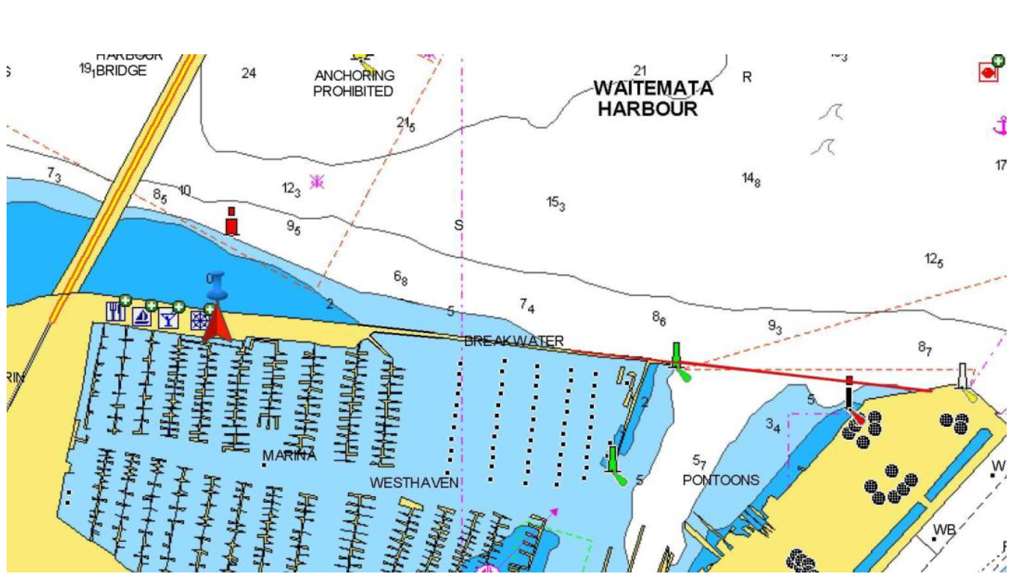

Diagram B - Auckland Ferry Terminal Basin Diagram C – Commercial Port Area
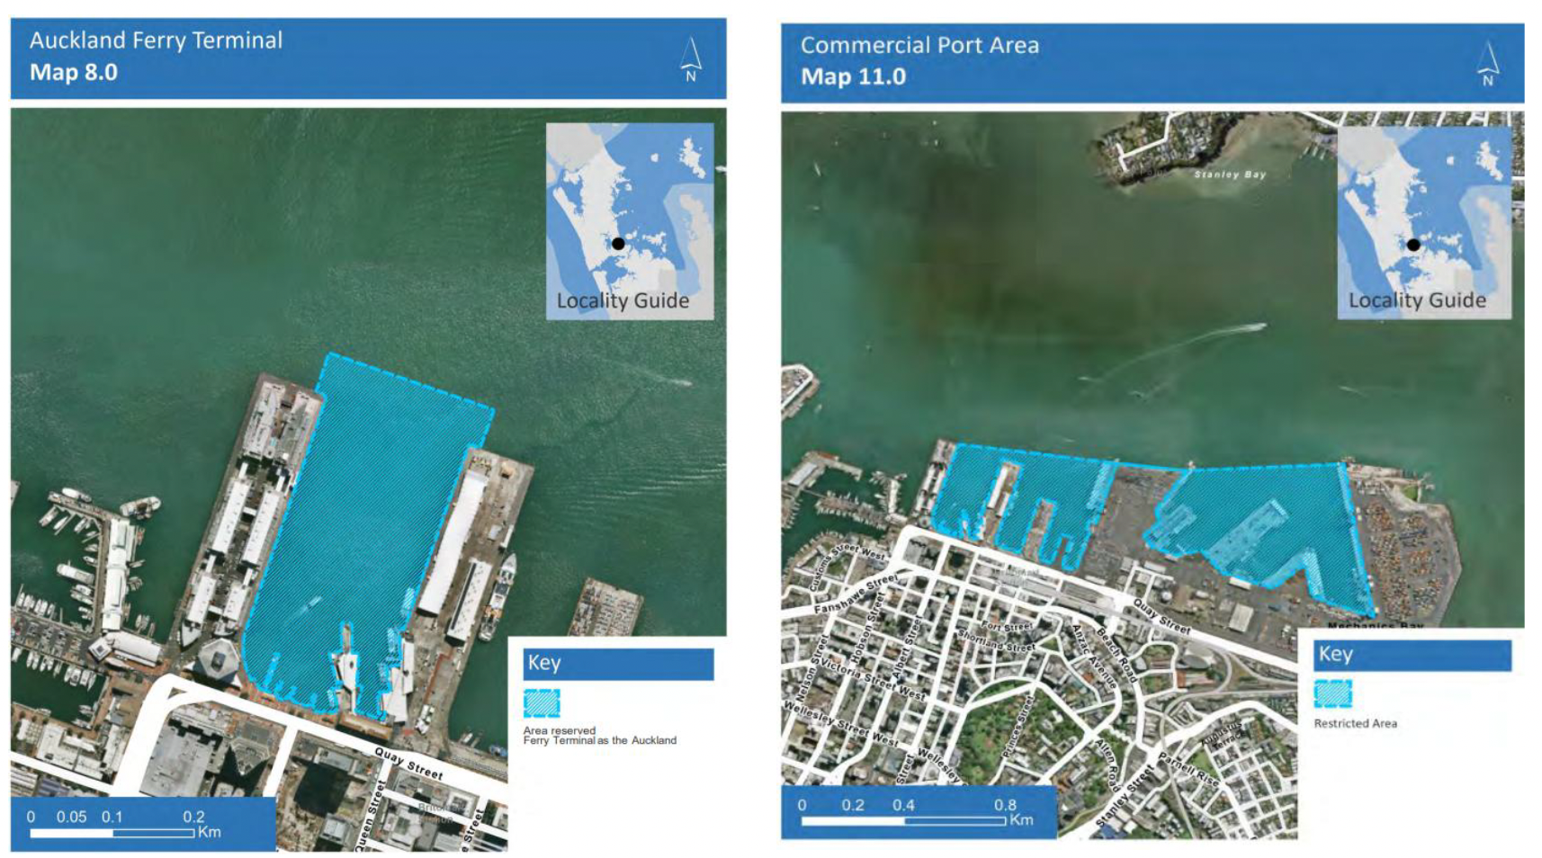

ADDENDUM A (continued)
Diagram D - Defence Area
